OFFICIAL COORDINATION REQUEST FOR
NON-ROUTINE OPERATIONS AND MAINTENANCE

COORDINATION TITLE- 24JDA16 – Extended 5-Year Maintenance to Hydraulically Lock Runner Blades on MU-2 and Delayed 5-Year Maintenance for MU-1
COORDINATION DATE- 9/20/24
PROJECT- John Day Dam
RESPONSE DATE- 10/10/2024

Description of the problem –

During the scheduled 5-year maintenance for MU-2, it was discovered that the O-ring between the hub and turbine shaft was leaking oil. It has been recommended that the most efficient solution to return the unit to service would be to hydraulically lock the runner blades at 29° eliminating the need for oil within the hub. Hydraulically locking the runner blades would lock the unit in the 135-148 MW range, allowing the unit to be operated within the HDC recommended range. The process will extend the current unit outage until mid-January 2025. The alternative would be to do a complete unstack of the unit resulting in the unit to be out of service for a minimum of 3 years.

The delayed return of MU-2 also affects the scheduled 5-year maintenance for MU-1. Due to the number of units already out of service, MU-1’s maintenance will be delayed until mid-January 2025 when MU-2 is returned to service. The outage for MU-1 would be expected to extend until mid-March 2025 effecting the FPP unit priority for the start of the fish passage season.

Type of outage required –

Extended outage to hydraulically lock runner blades on MU-2 and delayed 5-year maintenance for MU-1.

Impact on facility operation –

The primary impact is to the unit priority to start the fish passage season. MU-2 will be operated as required by the FPP while the maintenance is completed on MU-1 (FPP, John Day, 3.2.3.1).

Dates of impacts/repairs –

- MU-2 - 15 July 2024 – estimated 10 January 2025
- MU-1 – 20 January 2025 – estimated 13 March 2025

Length of time for repairs –

- MU-2 is estimated to require 3 months for the repairs.
- MU-1’s 5-year maintenance would take 7-8 weeks.

Analysis of potential impacts to fish-

Impacts to adult fish attraction should be minimal due to low abundances of adult fish migrating through John Day fish ladders in early March.

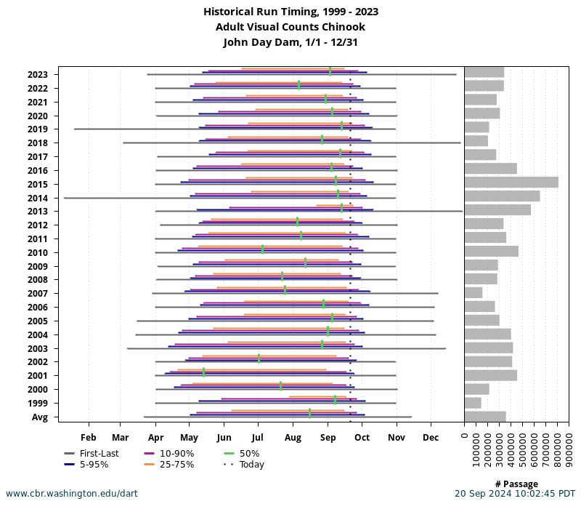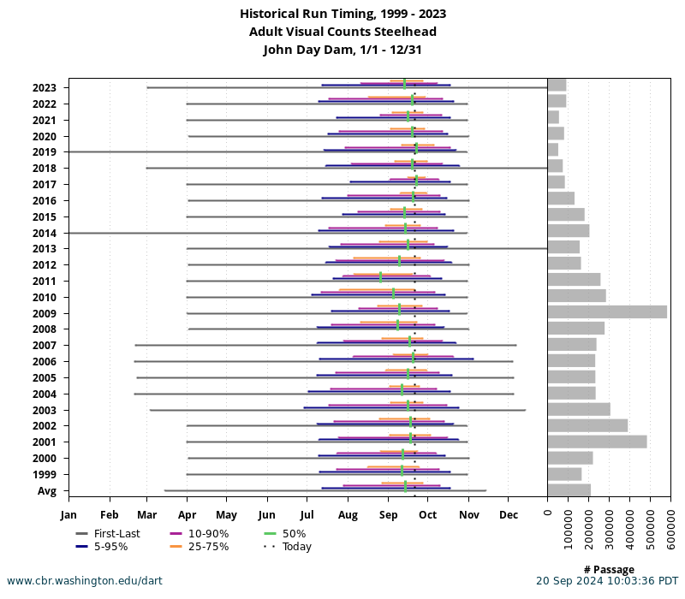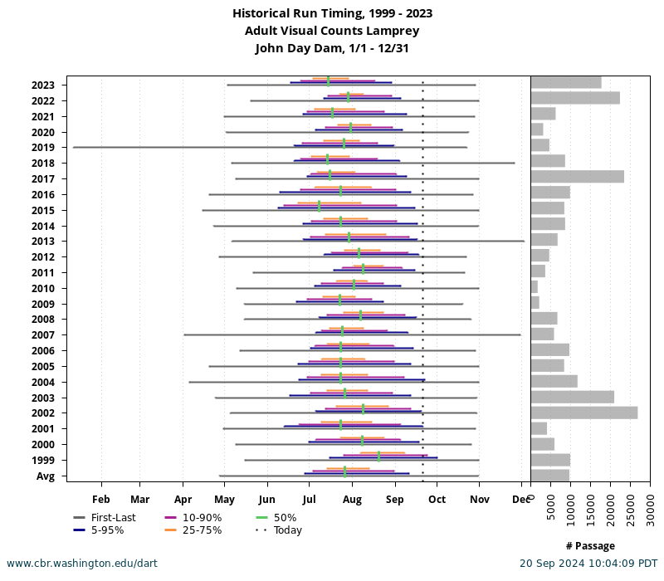

Summary statement – expected impacts on:

Impacts to early spring migrants is expected to be low due to the low historical numbers of adult fish utilizing the adult ladders in early March.

Downstream migrants: There is expected to be no impact to downstream migrants.

Upstream migrants (including Bull Trout): There is expected to be minimal to no impact to upstream migrants.
Lamprey: There is no expected impact to Lamprey.

Comments from agencies

Final coordination results

Please email or call with questions or concerns.
Thank you,

David Miller
Chief of Fisheries
John Day Dam
David.l.miller@usace.army.mil
541-739-1063

